**CA LAB-IV (A) LAB on Java Programming Assignments**

**Assignment 1) Write a program that demonstrate program structure of java with use of arithmetical and logical implementation.**

public class Assignment1

{

public static void main(String[] args)

{

// initializing variables

int num1 = 20, num2 = 10, sum = 0,diff = 0,multi=0;

float div=0;

System.out.println("num1 = " + num1);

System.out.println("num2 = " + num2);

sum = num1 + num2;

System.out.println("The sum = " + sum);

diff = num1 - num2;

System.out.println("The diff = " + diff);

multi = num1 * num2;

System.out.println("The multi = " + multi);

div = num1 / num2;

System.out.println("The div = " + div);

if ((num1==20) && (num2==10))// You can also use || operator

{

System.out.println("Both True");

}

else

System.out.println("Both Not True");

}

}

**OUTPUT:-**

num1 = 20

num2 = 10

The sum = 30

The diff = 10

The multi = 200

The div = 2.0

Both True

**Assignment 2) Write a program that demonstrate string operations using String and StringBuffer class.**

package assignment2;

import java.io.*;

public class Assignment2

{

public static void main(String[] args)

{

try

{

DataInputStream d= new DataInputStream(System.in);

System.out.println("\n enter the 1st String ");

String s=d.readLine();

//String Functions

int y=s.length();

System.out.println("\n length of string is "+y);

String z=s.toUpperCase();

System.out.println("\n string in upper case "+z);

String l=s.toLowerCase();

System.out.println("\n string in lower case "+l);

char m=s.charAt(3);

System.out.println("\n char at 3rd index is "+m);

String o=s.replace('a','b');

System.out.println("\n replaced string is "+o);

String n=s.substring(2,5);

System.out.println("\n sub string from 2 to 5 index is "+n);

System.out.println("\n enter the character to find index");

String s2=d.readLine();

int a=s.indexOf(s2);

System.out.println("\n index of char is "+a);

System.out.println("\n enter the character to find last index");

String s3=d.readLine();

int b=s.lastIndexOf(s3);

System.out.println("\n last index of char is "+b);

System.out.println("\n enter the 2nd String ");

String s1=d.readLine();

String p=s.concat(s1);

System.out.println("\n concated string is "+p);

boolean b1=s.equals(s1);

if(b1==true)

{

System.out.println("\n strings are equal ");

}

else

{

System.out.println("\n strings are not equal ");

}

//StringBuffer Functions

StringBuffer sf = new StringBuffer("Coding Atharva");

System.out.println("\n String = "+sf); // Will Print the string

System.out.println("\n Length = "+sf.length() ); // total numbers of characters

System.out.println("\n Length = "+sf.capacity() ); // total allocated capacity

sf.setLength(6); // Sets the length and destroy the remaining characters

System.out.println("\n After setting length String = "+sf);

sf.setCharAt(0,'K'); // It will change character at specified position

System.out.println("\n SetCharAt String = "+sf);

sf.setCharAt(0,'C');

int a1 = 7;

sf.append(a1); // It concatenates the other data type value

System.out.println("\n Appended String = "+sf);

sf.insert(6," Atharva"); // used to insert one string or char or object

System.out.println("\n Inserted String = "+sf);

sf.reverse();

System.out.println("\n Reverse String = "+sf);

}

catch(Exception e)

{

System.out.println(""+e);

}

}

}

**OUTPUT:-**

enter the 1st String

manojkumar

length of string is 10

string in upper case MANOJKUMAR

string in lower case manojkumar

char at 3rd index is o

replaced string is mbnojkumbr

sub string from 2 to 5 index is noj

enter the character to find index

a

index of char is 1

enter the character to find last index

a

last index of char is 8

enter the 2nd String

sonawane

concated string is manojkumarsonawane

strings are not equal

String = Coding Atharva

Length = 14

Length = 30

After setting length String = Coding

SetCharAt String = Koding

Appended String = Coding7

Inserted String = Coding Atharva7

Reverse String = 7avrahtA gnidoC

**Assignment 3) Write a program that demonstrate inner class and static fields.**

package assignment3;

class Outer

{

int outer_x = 100;

void test()

{

Inner inner = new Inner(); inner.display();

}

static int count=0;//will get memory only once and retain its value

Outer()

{

count++;//incrementing the value of static variable

System.out.println(count);

}

class Inner

{

void display()

{

System.out.println("display: outer_x = " + outer_x);

}

}

}

public class Assignment3

{

public static void main(String[] args)

{

Outer outer = new Outer();

outer.test();

//creating objects

Outer o1=new Outer();

Outer o2=new Outer();

Outer o3=new Outer();

}

}

**OUTPUT:-**

1

display: outer_x = 100

2

3

4

**Assignment 4) Write a program that demonstrate inheritance, polymorphism.**

package assignment4;

class Animal

{

public void move()

{

System.out.println("Animals can move");

}

}

class Dog extends Animal

{

//Method Overriding

public void move()

{

System.out.println("Dogs can walk and run");

}

//Method Overloading

void add(int a,int b)

{

int s=a+b;

System.out.println("Sum="+s);

}

void add(int a,int b,int c)

{

int s=a+b+c;

System.out.println("Sum="+s);

}

}

public class Assignment4

{

public static void main(String[] args)

{

Animal a =new Animal();

Animal b =new Dog();

a.move();

b.move();

Dog d=new Dog();

d.add(10,20);

d.add(10,20,30);

}

}

**OUTPUT:-**

Animals can move

Dogs can walk and run

Sum=30

Sum=60

**Assignment 5) Write a program that demonstrate 2D shapes on frames.**

Steps:-

1. Right Click on your project- New-JFrame
2. Drag JPanel on JFrame
3. Drag JButtons on JPanel
4. Right Click on JButtons-Edit Text
5. Right Click on JButtons-Events-select event/methods you want and write appropriate code.
6. Code

package assignment5;

**import java.awt.*;**

**import java.awt.geom.*;**

public class NewJFrame extends javax.swing.JFrame {

public NewJFrame() {

initComponents();

}

@SuppressWarnings("unchecked")

// <editor-fold defaultstate="collapsed" desc="Generated Code">

private void initComponents() {

jPanel1 = new javax.swing.JPanel();

jButton1 = new javax.swing.JButton();

jButton2 = new javax.swing.JButton();

jButton4 = new javax.swing.JButton();

setDefaultCloseOperation(javax.swing.WindowConstants.EXIT_ON_CLOSE);

jButton1.setText("Rectangle");

jButton1.addActionListener(new java.awt.event.ActionListener() {

public void actionPerformed(java.awt.event.ActionEvent evt) {

jButton1ActionPerformed(evt);

}

});

jButton2.setText("Ellipse");

jButton2.addActionListener(new java.awt.event.ActionListener() {

public void actionPerformed(java.awt.event.ActionEvent evt) {

jButton2ActionPerformed(evt);

}

});

jButton4.setText("Line");

jButton4.addActionListener(new java.awt.event.ActionListener() {

public void actionPerformed(java.awt.event.ActionEvent evt) {

jButton4ActionPerformed(evt);

}

});

javax.swing.GroupLayout jPanel1Layout = new javax.swing.GroupLayout(jPanel1);

jPanel1.setLayout(jPanel1Layout);

jPanel1Layout.setHorizontalGroup(

jPanel1Layout.createParallelGroup(javax.swing.GroupLayout.Alignment.LEADING)

.addGroup(jPanel1Layout.createSequentialGroup()

.addContainerGap()

.addComponent(jButton1)

.addGap(18, 18, 18)

.addComponent(jButton2)

.addGap(18, 18, 18)

.addComponent(jButton4)

.addContainerGap(92, Short.MAX_VALUE))

);

jPanel1Layout.setVerticalGroup(

jPanel1Layout.createParallelGroup(javax.swing.GroupLayout.Alignment.LEADING)

.addGroup(jPanel1Layout.createSequentialGroup()

.addGap(27, 27, 27)

.addGroup(jPanel1Layout.createParallelGroup(javax.swing.GroupLayout.Alignment.BASELINE)

.addComponent(jButton1)

.addComponent(jButton2)

.addComponent(jButton4))

.addContainerGap(228, Short.MAX_VALUE))

);

javax.swing.GroupLayout layout = new javax.swing.GroupLayout(getContentPane());

getContentPane().setLayout(layout);

layout.setHorizontalGroup(

layout.createParallelGroup(javax.swing.GroupLayout.Alignment.LEADING)

.addGroup(layout.createSequentialGroup()

.addContainerGap()

.addComponent(jPanel1, javax.swing.GroupLayout.PREFERRED_SIZE, javax.swing.GroupLayout.DEFAULT_SIZE, javax.swing.GroupLayout.PREFERRED_SIZE)

.addContainerGap(59, Short.MAX_VALUE))

);

layout.setVerticalGroup(

layout.createParallelGroup(javax.swing.GroupLayout.Alignment.LEADING)

.addGroup(layout.createSequentialGroup()

.addContainerGap()

.addComponent(jPanel1, javax.swing.GroupLayout.DEFAULT_SIZE, javax.swing.GroupLayout.DEFAULT_SIZE, Short.MAX_VALUE)

.addContainerGap())

);

pack();

}// </editor-fold>

private void jButton1ActionPerformed(java.awt.event.ActionEvent evt) {

// TODO add your handling code here:

**Graphics g1=jPanel1.getGraphics();**

**Graphics2D g2 = (Graphics2D)g1;**

**g2.setPaint(Color.ORANGE);**

**double leftx=100;**

**double topy=100;**

**double width=100;**

**double height=200;//For Squre width and height should be same**

**Rectangle2D rect = new Rectangle2D.Double(leftx,topy,leftx+width,topy+height);**

**g2.fill(rect);**

}

private void jButton2ActionPerformed(java.awt.event.ActionEvent evt) {

// TODO add your handling code here:

**Graphics g1=jPanel1.getGraphics();**

**Graphics2D g2 = (Graphics2D)g1;**

**g2.setPaint(Color.CYAN);**

**double leftx=300;**

**double topy=100;**

**double width=30;**

**double height=40;//For Circle width and height should be same**

**Ellipse2D ellipse = new Ellipse2D.Double(leftx,topy,width,height);**

**g2.fill(ellipse);**

}

private void jButton4ActionPerformed(java.awt.event.ActionEvent evt) {

// TODO add your handling code here:

**Graphics g1=jPanel1.getGraphics();**

**Graphics2D g2 = (Graphics2D)g1;**

**g2.setPaint(Color.MAGENTA);**

**double startx=50;**

**double starty=60;**

**double endx=600;**

**double endy=600;**

**Line2D line = new Line2D.Double(startx,starty,endx,endy);**

**g2.draw(line);**

}

public static void main(String args[]) {

/* Set the Nimbus look and feel */

//<editor-fold defaultstate="collapsed" desc=" Look and feel setting code (optional) ">

/* If Nimbus (introduced in Java SE 6) is not available, stay with the default look and feel.

* For details see http://download.oracle.com/javase/tutorial/uiswing/lookandfeel/plaf.html

*/

try {

for (javax.swing.UIManager.LookAndFeelInfo info : javax.swing.UIManager.getInstalledLookAndFeels()) {

if ("Nimbus".equals(info.getName())) {

javax.swing.UIManager.setLookAndFeel(info.getClassName());

break;

}

}

} catch (ClassNotFoundException ex) {

java.util.logging.Logger.getLogger(NewJFrame.class.getName()).log(java.util.logging.Level.SEVERE, null, ex);

} catch (InstantiationException ex) {

java.util.logging.Logger.getLogger(NewJFrame.class.getName()).log(java.util.logging.Level.SEVERE, null, ex);

} catch (IllegalAccessException ex) {

java.util.logging.Logger.getLogger(NewJFrame.class.getName()).log(java.util.logging.Level.SEVERE, null, ex);

} catch (javax.swing.UnsupportedLookAndFeelException ex) {

java.util.logging.Logger.getLogger(NewJFrame.class.getName()).log(java.util.logging.Level.SEVERE, null, ex);

}

//</editor-fold>

/* Create and display the form */

java.awt.EventQueue.invokeLater(new Runnable() {

public void run() {

new NewJFrame().setVisible(true);

}

});

}

// Variables declaration - do not modify

private javax.swing.JButton jButton1;

private javax.swing.JButton jButton2;

private javax.swing.JButton jButton4;

private javax.swing.JPanel jPanel1;

// End of variables declaration

}

1. Right Click in Code-Run File

**OUTPUT:-**

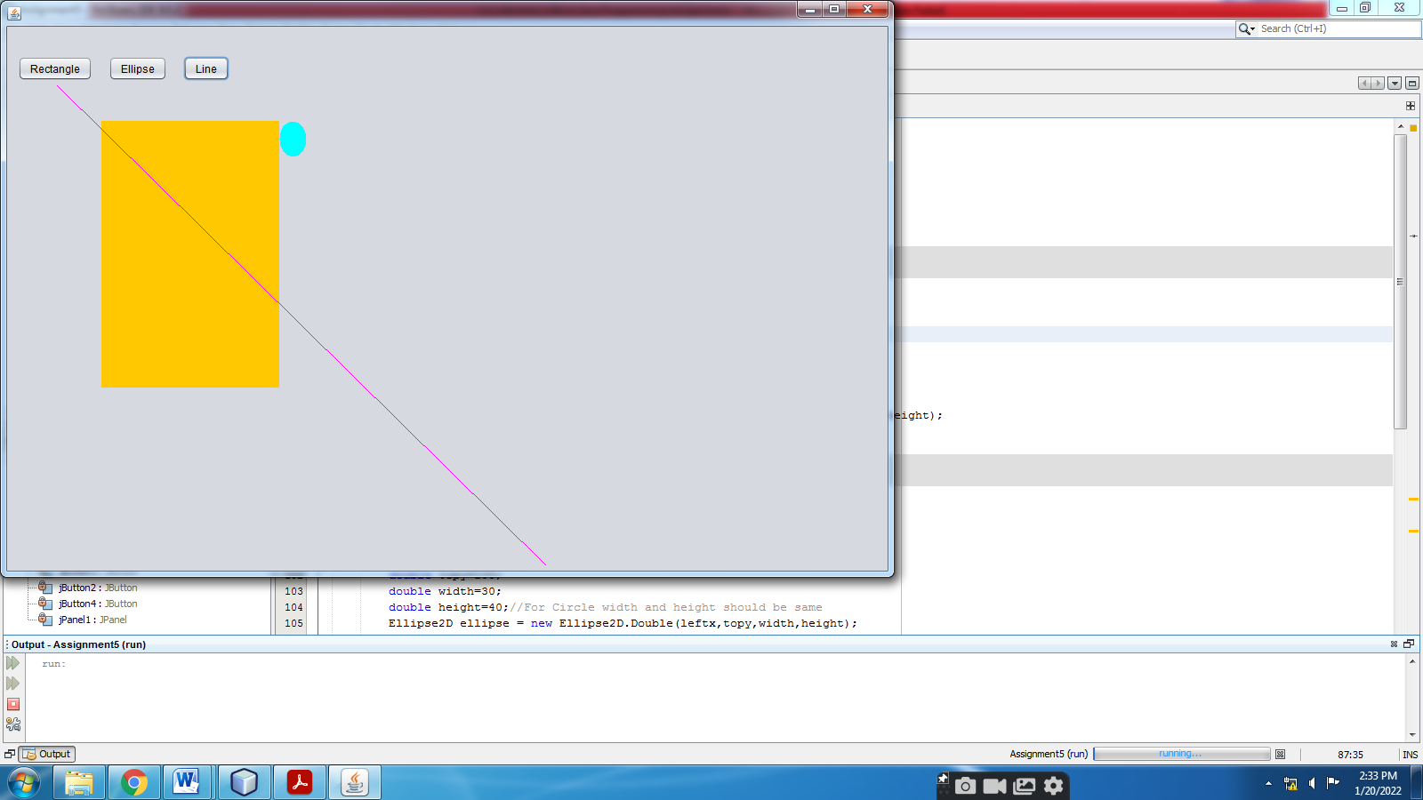

**Assignment 6) Write a program that demonstrate color and fonts.**

Steps:-

1. Right Click on your project- New-JFrame
2. Drag JPanel on JFrame
3. Drag JButton on JPanel
4. Right Click on JButton-Edit Text
5. Right Click on JButton-Events-select event/methods you want and write appropriate code.
6. Code

**import java.awt.*;**

**import java.awt.geom.*;**

**import java.util.*;**

public class NewJFrame extends javax.swing.JFrame {

public NewJFrame() {

initComponents();

}

@SuppressWarnings("unchecked")

// <editor-fold defaultstate="collapsed" desc="Generated Code">

private void initComponents() {

jPanel1 = new javax.swing.JPanel();

jButton1 = new javax.swing.JButton();

setDefaultCloseOperation(javax.swing.WindowConstants.EXIT_ON_CLOSE);

jButton1.setText("Click");

jButton1.addActionListener(new java.awt.event.ActionListener() {

public void actionPerformed(java.awt.event.ActionEvent evt) {

jButton1ActionPerformed(evt);

}

});

javax.swing.GroupLayout jPanel1Layout = new javax.swing.GroupLayout(jPanel1);

jPanel1.setLayout(jPanel1Layout);

jPanel1Layout.setHorizontalGroup(

jPanel1Layout.createParallelGroup(javax.swing.GroupLayout.Alignment.LEADING)

.addGroup(jPanel1Layout.createSequentialGroup()

.addGap(213, 213, 213)

.addComponent(jButton1)

.addContainerGap(667, Short.MAX_VALUE))

);

jPanel1Layout.setVerticalGroup(

jPanel1Layout.createParallelGroup(javax.swing.GroupLayout.Alignment.LEADING)

.addGroup(jPanel1Layout.createSequentialGroup()

.addComponent(jButton1)

.addGap(0, 578, Short.MAX_VALUE))

);

javax.swing.GroupLayout layout = new javax.swing.GroupLayout(getContentPane());

getContentPane().setLayout(layout);

layout.setHorizontalGroup(

layout.createParallelGroup(javax.swing.GroupLayout.Alignment.LEADING)

.addGroup(layout.createSequentialGroup()

.addGap(20, 20, 20)

.addComponent(jPanel1, javax.swing.GroupLayout.PREFERRED_SIZE, javax.swing.GroupLayout.DEFAULT_SIZE, javax.swing.GroupLayout.PREFERRED_SIZE)

.addContainerGap(55, Short.MAX_VALUE))

);

layout.setVerticalGroup(

layout.createParallelGroup(javax.swing.GroupLayout.Alignment.LEADING)

.addGroup(layout.createSequentialGroup()

.addGap(22, 22, 22)

.addComponent(jPanel1, javax.swing.GroupLayout.DEFAULT_SIZE, javax.swing.GroupLayout.DEFAULT_SIZE, Short.MAX_VALUE)

.addContainerGap())

);

pack();

}// </editor-fold>

private void jButton1ActionPerformed(java.awt.event.ActionEvent evt) {

// TODO add your handling code here:

**GraphicsEnvironment ge=GraphicsEnvironment.getLocalGraphicsEnvironment();**

**String s[]=ge.getAvailableFontFamilyNames();**

**Graphics g1=jPanel1.getGraphics();**

**Random rd = new Random();**

**int y=50;**

**int sz=20;**

**for(int i=0;i<s.length;i++)**

**{**

**Font f=new Font(s[i],Font.BOLD,sz);//Font.ITALIC**

**g1.setFont(f);**

**int r=rd.nextInt(255);**

**int g=rd.nextInt(255);**

**int b=rd.nextInt(255);**

**Color c=new Color(r,g,b);**

**g1.setColor(c);**

**g1.drawString("Hello World",50,y);**

**y=y+20;**

**sz=sz+1;**

**}**

}

public static void main(String args[]) {

/* Set the Nimbus look and feel */

//<editor-fold defaultstate="collapsed" desc=" Look and feel setting code (optional) ">

/* If Nimbus (introduced in Java SE 6) is not available, stay with the default look and feel.

* For details see http://download.oracle.com/javase/tutorial/uiswing/lookandfeel/plaf.html

*/

try {

for (javax.swing.UIManager.LookAndFeelInfo info : javax.swing.UIManager.getInstalledLookAndFeels()) {

if ("Nimbus".equals(info.getName())) {

javax.swing.UIManager.setLookAndFeel(info.getClassName());

break;

}

}

} catch (ClassNotFoundException ex) {

java.util.logging.Logger.getLogger(NewJFrame.class.getName()).log(java.util.logging.Level.SEVERE, null, ex);

} catch (InstantiationException ex) {

java.util.logging.Logger.getLogger(NewJFrame.class.getName()).log(java.util.logging.Level.SEVERE, null, ex);

} catch (IllegalAccessException ex) {

java.util.logging.Logger.getLogger(NewJFrame.class.getName()).log(java.util.logging.Level.SEVERE, null, ex);

} catch (javax.swing.UnsupportedLookAndFeelException ex) {

java.util.logging.Logger.getLogger(NewJFrame.class.getName()).log(java.util.logging.Level.SEVERE, null, ex);

}

//</editor-fold>

/* Create and display the form */

java.awt.EventQueue.invokeLater(new Runnable() {

public void run() {

new NewJFrame().setVisible(true);

}

});

}

// Variables declaration - do not modify

private javax.swing.JButton jButton1;

private javax.swing.JPanel jPanel1;

// End of variables declaration

}

1. Right Click in Code-Run File

**OUTPUT:-**

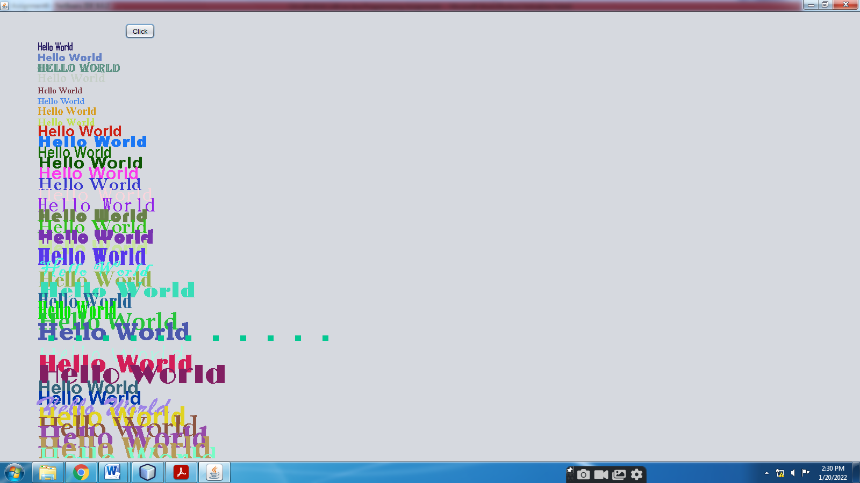

**Assignment 7) Write a program to illustrate use of various swing components.**

Steps:-

1. Right Click on your project- New-JFrame
2. Drag JPanel on JFrame
3. Drag various components
4. Right Click on components-Edit Text
5. Drag **ButtonGroup** component and set **buttonGroup** property of radiobuttons**.**
6. Right Click on jComboBox, jList1 and set **model** property.
7. Write Code on Button ActionPerformed

package assignment7;

public class NewJFrame extends javax.swing.JFrame {

public NewJFrame() {

initComponents();

}

@SuppressWarnings("unchecked")

// <editor-fold defaultstate="collapsed" desc="Generated Code">

private void initComponents() {

buttonGroup1 = new javax.swing.ButtonGroup();

jPanel1 = new javax.swing.JPanel();

jLabel1 = new javax.swing.JLabel();

jTextField1 = new javax.swing.JTextField();

jLabel2 = new javax.swing.JLabel();

jScrollPane1 = new javax.swing.JScrollPane();

jTextArea1 = new javax.swing.JTextArea();

jLabel3 = new javax.swing.JLabel();

jCheckBox1 = new javax.swing.JCheckBox();

jCheckBox2 = new javax.swing.JCheckBox();

jCheckBox3 = new javax.swing.JCheckBox();

jButton1 = new javax.swing.JButton();

jLabel4 = new javax.swing.JLabel();

jRadioButton1 = new javax.swing.JRadioButton();

jRadioButton2 = new javax.swing.JRadioButton();

jLabel5 = new javax.swing.JLabel();

jComboBox1 = new javax.swing.JComboBox();

jLabel6 = new javax.swing.JLabel();

jScrollPane2 = new javax.swing.JScrollPane();

jList1 = new javax.swing.JList();

setDefaultCloseOperation(javax.swing.WindowConstants.EXIT_ON_CLOSE);

jLabel1.setText("Enter Rno");

jLabel2.setText("Enter Name");

jTextArea1.setColumns(20);

jTextArea1.setRows(5);

jScrollPane1.setViewportView(jTextArea1);

jLabel3.setText("Favorite Color");

jCheckBox1.setText("Red");

jCheckBox2.setText("Green");

jCheckBox3.setText("Blue");

jButton1.setText("Click");

jButton1.addActionListener(new java.awt.event.ActionListener() {

public void actionPerformed(java.awt.event.ActionEvent evt) {

jButton1ActionPerformed(evt);

}

});

jLabel4.setText("Class");

buttonGroup1.add(jRadioButton1);

jRadioButton1.setText("MCA-1");

buttonGroup1.add(jRadioButton2);

jRadioButton2.setText("MCA-2");

jLabel5.setText("Laptop");

jComboBox1.setModel(new javax.swing.DefaultComboBoxModel(new String[] { "HP", "Dell", "Lenovo" }));

jLabel6.setText("Subject");

jList1.setModel(new javax.swing.AbstractListModel() {

String[] strings = { "C", "C++", "Java" };

public int getSize() { return strings.length; }

public Object getElementAt(int i) { return strings[i]; }

});

jScrollPane2.setViewportView(jList1);

javax.swing.GroupLayout jPanel1Layout = new javax.swing.GroupLayout(jPanel1);

jPanel1.setLayout(jPanel1Layout);

jPanel1Layout.setHorizontalGroup(

jPanel1Layout.createParallelGroup(javax.swing.GroupLayout.Alignment.LEADING)

.addGroup(jPanel1Layout.createSequentialGroup()

.addGap(35, 35, 35)

.addGroup(jPanel1Layout.createParallelGroup(javax.swing.GroupLayout.Alignment.LEADING)

.addGroup(jPanel1Layout.createSequentialGroup()

.addGroup(jPanel1Layout.createParallelGroup(javax.swing.GroupLayout.Alignment.TRAILING, false)

.addComponent(jLabel6, javax.swing.GroupLayout.Alignment.LEADING, javax.swing.GroupLayout.DEFAULT_SIZE, 62, Short.MAX_VALUE)

.addComponent(jLabel5, javax.swing.GroupLayout.Alignment.LEADING, javax.swing.GroupLayout.DEFAULT_SIZE, javax.swing.GroupLayout.DEFAULT_SIZE, Short.MAX_VALUE))

.addGap(44, 44, 44)

.addGroup(jPanel1Layout.createParallelGroup(javax.swing.GroupLayout.Alignment.LEADING)

.addComponent(jComboBox1, javax.swing.GroupLayout.PREFERRED_SIZE, javax.swing.GroupLayout.DEFAULT_SIZE, javax.swing.GroupLayout.PREFERRED_SIZE)

.addComponent(jScrollPane2, javax.swing.GroupLayout.PREFERRED_SIZE, 68, javax.swing.GroupLayout.PREFERRED_SIZE)

.addComponent(jButton1, javax.swing.GroupLayout.PREFERRED_SIZE, 92, javax.swing.GroupLayout.PREFERRED_SIZE)))

.addGroup(jPanel1Layout.createSequentialGroup()

.addGroup(jPanel1Layout.createParallelGroup(javax.swing.GroupLayout.Alignment.LEADING)

.addComponent(jLabel1, javax.swing.GroupLayout.PREFERRED_SIZE, 68, javax.swing.GroupLayout.PREFERRED_SIZE)

.addComponent(jLabel2, javax.swing.GroupLayout.PREFERRED_SIZE, 68, javax.swing.GroupLayout.PREFERRED_SIZE)

.addComponent(jLabel3, javax.swing.GroupLayout.PREFERRED_SIZE, 96, javax.swing.GroupLayout.PREFERRED_SIZE)

.addComponent(jLabel4, javax.swing.GroupLayout.PREFERRED_SIZE, 50, javax.swing.GroupLayout.PREFERRED_SIZE))

.addGroup(jPanel1Layout.createParallelGroup(javax.swing.GroupLayout.Alignment.LEADING)

.addGroup(jPanel1Layout.createSequentialGroup()

.addGap(25, 25, 25)

.addGroup(jPanel1Layout.createParallelGroup(javax.swing.GroupLayout.Alignment.LEADING)

.addComponent(jCheckBox1)

.addComponent(jCheckBox2)

.addComponent(jCheckBox3)

.addComponent(jScrollPane1, javax.swing.GroupLayout.PREFERRED_SIZE, 146, javax.swing.GroupLayout.PREFERRED_SIZE)

.addComponent(jTextField1, javax.swing.GroupLayout.PREFERRED_SIZE, 89, javax.swing.GroupLayout.PREFERRED_SIZE)))

.addGroup(jPanel1Layout.createSequentialGroup()

.addGap(13, 13, 13)

.addGroup(jPanel1Layout.createParallelGroup(javax.swing.GroupLayout.Alignment.LEADING)

.addComponent(jRadioButton1)

.addComponent(jRadioButton2))))))

.addContainerGap(691, Short.MAX_VALUE))

);

jPanel1Layout.setVerticalGroup(

jPanel1Layout.createParallelGroup(javax.swing.GroupLayout.Alignment.LEADING)

.addGroup(jPanel1Layout.createSequentialGroup()

.addGap(55, 55, 55)

.addGroup(jPanel1Layout.createParallelGroup(javax.swing.GroupLayout.Alignment.BASELINE)

.addComponent(jLabel1, javax.swing.GroupLayout.PREFERRED_SIZE, 29, javax.swing.GroupLayout.PREFERRED_SIZE)

.addComponent(jTextField1, javax.swing.GroupLayout.PREFERRED_SIZE, 29, javax.swing.GroupLayout.PREFERRED_SIZE))

.addPreferredGap(javax.swing.LayoutStyle.ComponentPlacement.RELATED)

.addGroup(jPanel1Layout.createParallelGroup(javax.swing.GroupLayout.Alignment.LEADING)

.addComponent(jScrollPane1, javax.swing.GroupLayout.PREFERRED_SIZE, 62, javax.swing.GroupLayout.PREFERRED_SIZE)

.addComponent(jLabel2, javax.swing.GroupLayout.PREFERRED_SIZE, 25, javax.swing.GroupLayout.PREFERRED_SIZE))

.addGroup(jPanel1Layout.createParallelGroup(javax.swing.GroupLayout.Alignment.LEADING)

.addGroup(jPanel1Layout.createSequentialGroup()

.addGap(12, 12, 12)

.addComponent(jLabel3, javax.swing.GroupLayout.PREFERRED_SIZE, 35, javax.swing.GroupLayout.PREFERRED_SIZE))

.addGroup(jPanel1Layout.createSequentialGroup()

.addGap(18, 18, 18)

.addComponent(jCheckBox1)

.addPreferredGap(javax.swing.LayoutStyle.ComponentPlacement.UNRELATED)

.addComponent(jCheckBox2)

.addPreferredGap(javax.swing.LayoutStyle.ComponentPlacement.UNRELATED)

.addComponent(jCheckBox3)))

.addGroup(jPanel1Layout.createParallelGroup(javax.swing.GroupLayout.Alignment.LEADING)

.addGroup(jPanel1Layout.createSequentialGroup()

.addGap(21, 21, 21)

.addComponent(jRadioButton1)

.addPreferredGap(javax.swing.LayoutStyle.ComponentPlacement.RELATED)

.addComponent(jRadioButton2)

.addGap(23, 23, 23))

.addGroup(javax.swing.GroupLayout.Alignment.TRAILING, jPanel1Layout.createSequentialGroup()

.addPreferredGap(javax.swing.LayoutStyle.ComponentPlacement.RELATED)

.addComponent(jLabel4, javax.swing.GroupLayout.PREFERRED_SIZE, 25, javax.swing.GroupLayout.PREFERRED_SIZE)

.addGap(36, 36, 36)))

.addGroup(jPanel1Layout.createParallelGroup(javax.swing.GroupLayout.Alignment.TRAILING)

.addComponent(jLabel5, javax.swing.GroupLayout.PREFERRED_SIZE, 26, javax.swing.GroupLayout.PREFERRED_SIZE)

.addComponent(jComboBox1, javax.swing.GroupLayout.PREFERRED_SIZE, javax.swing.GroupLayout.DEFAULT_SIZE, javax.swing.GroupLayout.PREFERRED_SIZE))

.addGap(18, 18, 18)

.addGroup(jPanel1Layout.createParallelGroup(javax.swing.GroupLayout.Alignment.LEADING)

.addComponent(jLabel6, javax.swing.GroupLayout.PREFERRED_SIZE, 24, javax.swing.GroupLayout.PREFERRED_SIZE)

.addComponent(jScrollPane2, javax.swing.GroupLayout.PREFERRED_SIZE, 75, javax.swing.GroupLayout.PREFERRED_SIZE))

.addGap(31, 31, 31)

.addComponent(jButton1, javax.swing.GroupLayout.PREFERRED_SIZE, 37, javax.swing.GroupLayout.PREFERRED_SIZE)

.addContainerGap(64, Short.MAX_VALUE))

);

javax.swing.GroupLayout layout = new javax.swing.GroupLayout(getContentPane());

getContentPane().setLayout(layout);

layout.setHorizontalGroup(

layout.createParallelGroup(javax.swing.GroupLayout.Alignment.LEADING)

.addGroup(layout.createSequentialGroup()

.addComponent(jPanel1, javax.swing.GroupLayout.PREFERRED_SIZE, javax.swing.GroupLayout.DEFAULT_SIZE, javax.swing.GroupLayout.PREFERRED_SIZE)

.addGap(0, 0, Short.MAX_VALUE))

);

layout.setVerticalGroup(

layout.createParallelGroup(javax.swing.GroupLayout.Alignment.LEADING)

.addGroup(javax.swing.GroupLayout.Alignment.TRAILING, layout.createSequentialGroup()

.addContainerGap(javax.swing.GroupLayout.DEFAULT_SIZE, Short.MAX_VALUE)

.addComponent(jPanel1, javax.swing.GroupLayout.PREFERRED_SIZE, javax.swing.GroupLayout.DEFAULT_SIZE, javax.swing.GroupLayout.PREFERRED_SIZE)

.addContainerGap())

);

pack();

}// </editor-fold>

private void jButton1ActionPerformed(java.awt.event.ActionEvent evt) {

// TODO add your handling code here:

**System.out.println("Rno= "+jTextField1.getText());**

**System.out.println("Name= "+jTextArea1.getText());**

**String color=" ";**

**if (jCheckBox1.isSelected())**

**color=color+" "+jCheckBox1.getText();**

**if (jCheckBox2.isSelected())**

**color=color+" "+jCheckBox2.getText();**

**if (jCheckBox3.isSelected())**

**color=color+" "+jCheckBox3.getText();**

**System.out.println("Favorite Colors= "+color);**

**String cl=" ";**

**if (jRadioButton1.isSelected())**

**cl=cl+" "+jRadioButton1.getText();**

**else**

**cl=cl+" "+jRadioButton2.getText();**

**System.out.println("Class= "+cl);**

**System.out.println("Laptop= "+jComboBox1.getSelectedItem().toString());**

**System.out.println("Subjects= ");**

**Object o[]=jList1.getSelectedValues();**

**for(int i=0;i<o.length;i++)**

**{**

**System.out.println(o[i].toString());**

**}**

}

public static void main(String args[]) {

/* Set the Nimbus look and feel */

//<editor-fold defaultstate="collapsed" desc=" Look and feel setting code (optional) ">

/* If Nimbus (introduced in Java SE 6) is not available, stay with the default look and feel.

* For details see http://download.oracle.com/javase/tutorial/uiswing/lookandfeel/plaf.html

*/

try {

for (javax.swing.UIManager.LookAndFeelInfo info : javax.swing.UIManager.getInstalledLookAndFeels()) {

if ("Nimbus".equals(info.getName())) {

javax.swing.UIManager.setLookAndFeel(info.getClassName());

break;

}

}

} catch (ClassNotFoundException ex) {

java.util.logging.Logger.getLogger(NewJFrame.class.getName()).log(java.util.logging.Level.SEVERE, null, ex);

} catch (InstantiationException ex) {

java.util.logging.Logger.getLogger(NewJFrame.class.getName()).log(java.util.logging.Level.SEVERE, null, ex);

} catch (IllegalAccessException ex) {

java.util.logging.Logger.getLogger(NewJFrame.class.getName()).log(java.util.logging.Level.SEVERE, null, ex);

} catch (javax.swing.UnsupportedLookAndFeelException ex) {

java.util.logging.Logger.getLogger(NewJFrame.class.getName()).log(java.util.logging.Level.SEVERE, null, ex);

}

//</editor-fold>

/* Create and display the form */

java.awt.EventQueue.invokeLater(new Runnable() {

public void run() {

new NewJFrame().setVisible(true);

}

});

}

// Variables declaration - do not modify

private javax.swing.ButtonGroup buttonGroup1;

private javax.swing.JButton jButton1;

private javax.swing.JCheckBox jCheckBox1;

private javax.swing.JCheckBox jCheckBox2;

private javax.swing.JCheckBox jCheckBox3;

private javax.swing.JComboBox jComboBox1;

private javax.swing.JLabel jLabel1;

private javax.swing.JLabel jLabel2;

private javax.swing.JLabel jLabel3;

private javax.swing.JLabel jLabel4;

private javax.swing.JLabel jLabel5;

private javax.swing.JLabel jLabel6;

private javax.swing.JList jList1;

private javax.swing.JPanel jPanel1;

private javax.swing.JRadioButton jRadioButton1;

private javax.swing.JRadioButton jRadioButton2;

private javax.swing.JScrollPane jScrollPane1;

private javax.swing.JScrollPane jScrollPane2;

private javax.swing.JTextArea jTextArea1;

private javax.swing.JTextField jTextField1;

// End of variables declaration

}

1. Right Click in Code-Run File

**OUTPUT:-**

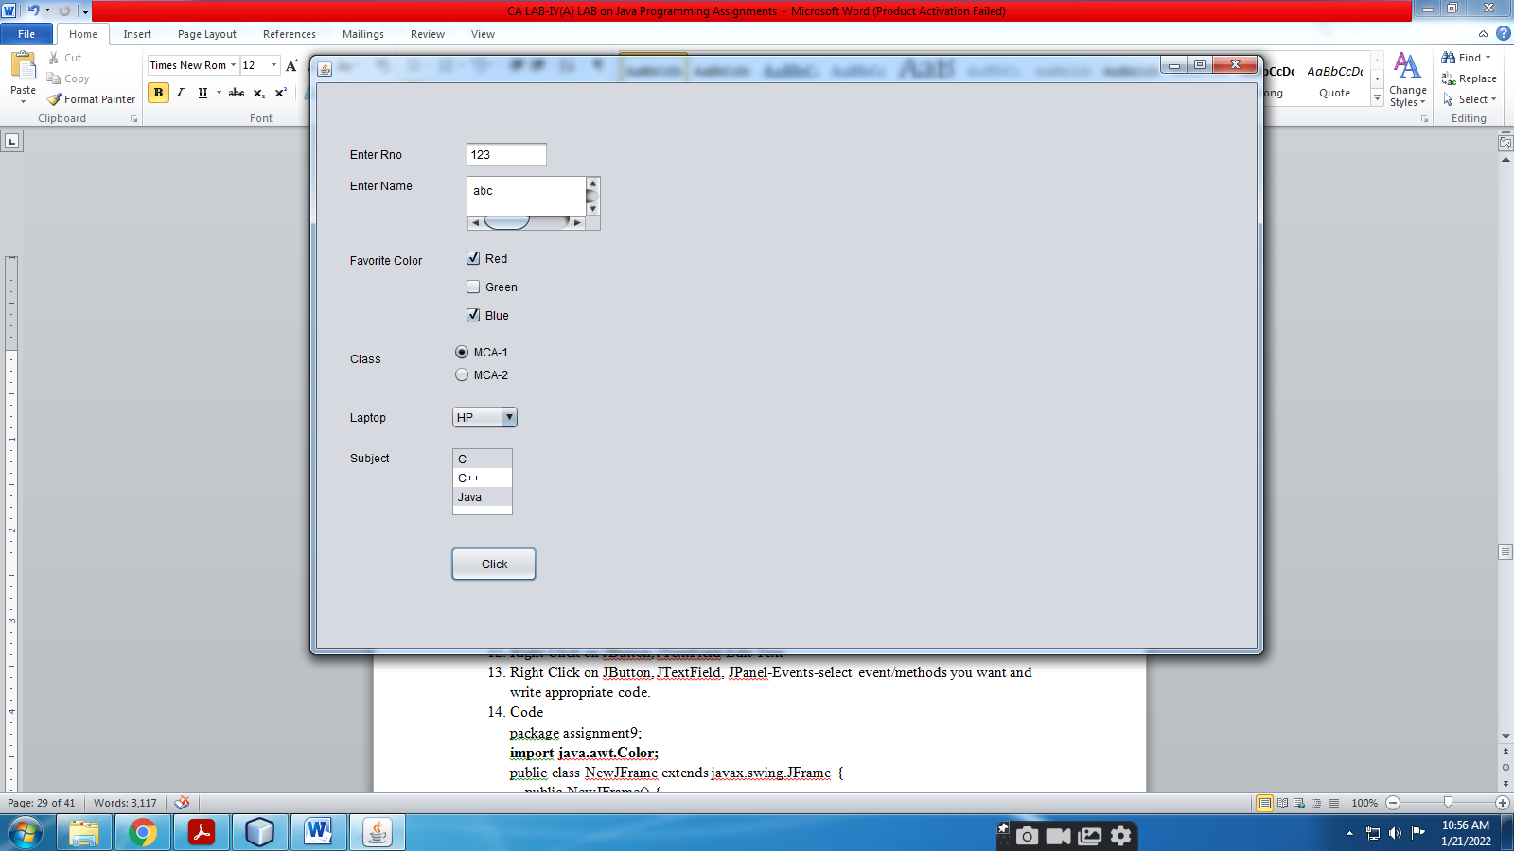

**Assignment 8) Write a program that demonstrate use of dialog box and menus.**

Steps:-

1. Right Click on your project- New-JFrame
2. Drag JPanel on JFrame
3. Drag **JMenuBar**--Edit Text
4. Right Click on JMenuBar-select **Add From Palette-MenuItem/Separator**.
5. Right Click on MenuItem-select event/methods you want.
6. Drag **Popup Menu** onJPanel and add MenuItem, event/methods in it similarly.
7. Right Click on your JPanel, set **componentPopupMenu** property to your popup menu.
8. For User DialogBox- Drag **JDialog** on JPanel, Right Click on your JDialog-**setLayout,** Right Click on your JDialog-**Add From Palette-Swing Controls.**
9. Write Following Code

package assignment8;

**import javax.swing.*;**

**import java.io.*;**

**import java.awt.*;**

public class NewJFrame extends javax.swing.JFrame {

public NewJFrame() {

initComponents();

}

@SuppressWarnings("unchecked")

// <editor-fold defaultstate="collapsed" desc="Generated Code">

private void initComponents() {

jPopupMenu1 = new javax.swing.JPopupMenu();

Red = new javax.swing.JMenuItem();

Green = new javax.swing.JMenuItem();

Blue = new javax.swing.JMenuItem();

jDialog1 = new javax.swing.JDialog();

jTextField1 = new javax.swing.JTextField();

Click = new javax.swing.JButton();

jPanel1 = new javax.swing.JPanel();

jMenuBar1 = new javax.swing.JMenuBar();

jMenu1 = new javax.swing.JMenu();

jMenuItem1 = new javax.swing.JMenuItem();

jSeparator1 = new javax.swing.JPopupMenu.Separator();

jMenuItem2 = new javax.swing.JMenuItem();

jSeparator2 = new javax.swing.JPopupMenu.Separator();

jCheckBoxMenuItem1 = new javax.swing.JCheckBoxMenuItem();

jSeparator3 = new javax.swing.JPopupMenu.Separator();

jRadioButtonMenuItem1 = new javax.swing.JRadioButtonMenuItem();

jSeparator5 = new javax.swing.JPopupMenu.Separator();

jMenuItem6 = new javax.swing.JMenuItem();

jSeparator4 = new javax.swing.JPopupMenu.Separator();

jMenuItem4 = new javax.swing.JMenuItem();

jMenu2 = new javax.swing.JMenu();

jMenuItem3 = new javax.swing.JMenuItem();

Red.setText("Red");

Red.addActionListener(new java.awt.event.ActionListener() {

public void actionPerformed(java.awt.event.ActionEvent evt) {

RedActionPerformed(evt);

}

});

jPopupMenu1.add(Red);

Green.setText("Green");

Green.addActionListener(new java.awt.event.ActionListener() {

public void actionPerformed(java.awt.event.ActionEvent evt) {

GreenActionPerformed(evt);

}

});

jPopupMenu1.add(Green);

Blue.setText("Blue");

Blue.addActionListener(new java.awt.event.ActionListener() {

public void actionPerformed(java.awt.event.ActionEvent evt) {

BlueActionPerformed(evt);

}

});

jPopupMenu1.add(Blue);

jDialog1.getContentPane().setLayout(new java.awt.FlowLayout());

jTextField1.setText("jTextField1");

jDialog1.getContentPane().add(jTextField1);

Click.setText("Click");

jDialog1.getContentPane().add(Click);

setDefaultCloseOperation(javax.swing.WindowConstants.EXIT_ON_CLOSE);

jPanel1.setComponentPopupMenu(jPopupMenu1);

javax.swing.GroupLayout jPanel1Layout = new javax.swing.GroupLayout(jPanel1);

jPanel1.setLayout(jPanel1Layout);

jPanel1Layout.setHorizontalGroup(

jPanel1Layout.createParallelGroup(javax.swing.GroupLayout.Alignment.LEADING)

.addGap(0, 958, Short.MAX_VALUE)

);

jPanel1Layout.setVerticalGroup(

jPanel1Layout.createParallelGroup(javax.swing.GroupLayout.Alignment.LEADING)

.addGap(0, 581, Short.MAX_VALUE)

);

jMenu1.setText("File");

jMenu1.addActionListener(new java.awt.event.ActionListener() {

public void actionPerformed(java.awt.event.ActionEvent evt) {

jMenu1ActionPerformed(evt);

}

});

jMenuItem1.setAccelerator(javax.swing.KeyStroke.getKeyStroke(java.awt.event.KeyEvent.VK_A, java.awt.event.InputEvent.CTRL_MASK));

jMenuItem1.setText("InputDialogBox");

jMenuItem1.addActionListener(new java.awt.event.ActionListener() {

public void actionPerformed(java.awt.event.ActionEvent evt) {

jMenuItem1ActionPerformed(evt);

}

});

jMenu1.add(jMenuItem1);

jMenu1.add(jSeparator1);

jMenuItem2.setAccelerator(javax.swing.KeyStroke.getKeyStroke(java.awt.event.KeyEvent.VK_B, java.awt.event.InputEvent.CTRL_MASK));

jMenuItem2.setText("MessageDialogBox");

jMenuItem2.addActionListener(new java.awt.event.ActionListener() {

public void actionPerformed(java.awt.event.ActionEvent evt) {

jMenuItem2ActionPerformed(evt);

}

});

jMenu1.add(jMenuItem2);

jMenu1.add(jSeparator2);

jCheckBoxMenuItem1.setAccelerator(javax.swing.KeyStroke.getKeyStroke(java.awt.event.KeyEvent.VK_C, java.awt.event.InputEvent.ALT_MASK));

jCheckBoxMenuItem1.setSelected(true);

jCheckBoxMenuItem1.setText("ConfirmDialogBox");

jCheckBoxMenuItem1.addActionListener(new java.awt.event.ActionListener() {

public void actionPerformed(java.awt.event.ActionEvent evt) {

jCheckBoxMenuItem1ActionPerformed(evt);

}

});

jMenu1.add(jCheckBoxMenuItem1);

jMenu1.add(jSeparator3);

jRadioButtonMenuItem1.setAccelerator(javax.swing.KeyStroke.getKeyStroke(java.awt.event.KeyEvent.VK_D, java.awt.event.InputEvent.SHIFT_MASK));

jRadioButtonMenuItem1.setSelected(true);

jRadioButtonMenuItem1.setText("OptionDialogBox");

jRadioButtonMenuItem1.addActionListener(new java.awt.event.ActionListener() {

public void actionPerformed(java.awt.event.ActionEvent evt) {

jRadioButtonMenuItem1ActionPerformed(evt);

}

});

jMenu1.add(jRadioButtonMenuItem1);

jMenu1.add(jSeparator5);

jMenuItem6.setText("FileChooser");

jMenuItem6.addActionListener(new java.awt.event.ActionListener() {

public void actionPerformed(java.awt.event.ActionEvent evt) {

jMenuItem6ActionPerformed(evt);

}

});

jMenu1.add(jMenuItem6);

jMenu1.add(jSeparator4);

jMenuItem4.setText("ColorChooser");

jMenuItem4.addActionListener(new java.awt.event.ActionListener() {

public void actionPerformed(java.awt.event.ActionEvent evt) {

jMenuItem4ActionPerformed(evt);

}

});

jMenu1.add(jMenuItem4);

jMenuBar1.add(jMenu1);

jMenu2.setText("Edit");

jMenuItem3.setText("UserDialogBox");

jMenuItem3.addActionListener(new java.awt.event.ActionListener() {

public void actionPerformed(java.awt.event.ActionEvent evt) {

jMenuItem3ActionPerformed(evt);

}

});

jMenu2.add(jMenuItem3);

jMenuBar1.add(jMenu2);

setJMenuBar(jMenuBar1);

javax.swing.GroupLayout layout = new javax.swing.GroupLayout(getContentPane());

getContentPane().setLayout(layout);

layout.setHorizontalGroup(

layout.createParallelGroup(javax.swing.GroupLayout.Alignment.LEADING)

.addGroup(layout.createSequentialGroup()

.addGap(28, 28, 28)

.addComponent(jPanel1, javax.swing.GroupLayout.PREFERRED_SIZE, javax.swing.GroupLayout.DEFAULT_SIZE, javax.swing.GroupLayout.PREFERRED_SIZE)

.addContainerGap(26, Short.MAX_VALUE))

);

layout.setVerticalGroup(

layout.createParallelGroup(javax.swing.GroupLayout.Alignment.LEADING)

.addGroup(layout.createSequentialGroup()

.addGap(35, 35, 35)

.addComponent(jPanel1, javax.swing.GroupLayout.PREFERRED_SIZE, javax.swing.GroupLayout.DEFAULT_SIZE, javax.swing.GroupLayout.PREFERRED_SIZE)

.addContainerGap(javax.swing.GroupLayout.DEFAULT_SIZE, Short.MAX_VALUE))

);

pack();

}// </editor-fold>

private void jMenuItem1ActionPerformed(java.awt.event.ActionEvent evt) {

// TODO add your handling code here:

**String n=JOptionPane.showInputDialog("Enter Name");**

**System.out.println("Name="+n);**

}

private void jMenuItem3ActionPerformed(java.awt.event.ActionEvent evt) {

// TODO add your handling code here:

**jDialog1.setTitle("This is my DialogBox");**

**jDialog1.setSize(222,222);**

**jDialog1.show();**

}

private void jMenuItem2ActionPerformed(java.awt.event.ActionEvent evt) {

// TODO add your handling code here:

**JOptionPane.showMessageDialog(null,"Success");**

}

private void jCheckBoxMenuItem1ActionPerformed(java.awt.event.ActionEvent evt) {

// TODO add your handling code here:

**int i=JOptionPane.showConfirmDialog(null, "Are you Sure?");**

**System.out.println(i);**

}

private void jRadioButtonMenuItem1ActionPerformed(java.awt.event.ActionEvent evt) {

// TODO add your handling code here:

**String[] options = {"first", "second", "third"};**

**int x = JOptionPane.showOptionDialog(null, "Select Option",**

**"OptionDialogBox",JOptionPane.DEFAULT_OPTION, JOptionPane.INFORMATION_MESSAGE, null, options, options[0]);**

**System.out.println("Your Option is "+x);**

}

private void RedActionPerformed(java.awt.event.ActionEvent evt) {

// TODO add your handling code here:

**jPanel1.setBackground(Color.red);**

}

private void GreenActionPerformed(java.awt.event.ActionEvent evt) {

// TODO add your handling code here:

**jPanel1.setBackground(Color.green);**

}

private void BlueActionPerformed(java.awt.event.ActionEvent evt) {

// TODO add your handling code here:

**jPanel1.setBackground(Color.blue);**

}

private void jMenu1ActionPerformed(java.awt.event.ActionEvent evt) {

// TODO add your handling code here:

}

private void jMenuItem6ActionPerformed(java.awt.event.ActionEvent evt) {

// TODO add your handling code here:

**JFileChooser fc=new JFileChooser();**

**int i=fc.showOpenDialog(this);**

**if(i==JFileChooser.APPROVE_OPTION)**

**{**

**File f=fc.getSelectedFile();**

**String filepath=f.getPath();**

**System.out.println("You Selected "+filepath);**

**}**

}

private void jMenuItem4ActionPerformed(java.awt.event.ActionEvent evt) {

// TODO add your handling code here:

**Color c=JColorChooser.showDialog(this,"Select a color",Color.ORANGE);**

**jPanel1.setBackground(c);**

}

public static void main(String args[]) {

/* Set the Nimbus look and feel */

//<editor-fold defaultstate="collapsed" desc=" Look and feel setting code (optional) ">

/* If Nimbus (introduced in Java SE 6) is not available, stay with the default look and feel.

* For details see http://download.oracle.com/javase/tutorial/uiswing/lookandfeel/plaf.html

*/

try {

for (javax.swing.UIManager.LookAndFeelInfo info : javax.swing.UIManager.getInstalledLookAndFeels()) {

if ("Nimbus".equals(info.getName())) {

javax.swing.UIManager.setLookAndFeel(info.getClassName());

break;

}

}

} catch (ClassNotFoundException ex) {

java.util.logging.Logger.getLogger(NewJFrame.class.getName()).log(java.util.logging.Level.SEVERE, null, ex);

} catch (InstantiationException ex) {

java.util.logging.Logger.getLogger(NewJFrame.class.getName()).log(java.util.logging.Level.SEVERE, null, ex);

} catch (IllegalAccessException ex) {

java.util.logging.Logger.getLogger(NewJFrame.class.getName()).log(java.util.logging.Level.SEVERE, null, ex);

} catch (javax.swing.UnsupportedLookAndFeelException ex) {

java.util.logging.Logger.getLogger(NewJFrame.class.getName()).log(java.util.logging.Level.SEVERE, null, ex);

}

//</editor-fold>

/* Create and display the form */

java.awt.EventQueue.invokeLater(new Runnable() {

public void run() {

new NewJFrame().setVisible(true);

}

});

}

// Variables declaration - do not modify

private javax.swing.JMenuItem Blue;

private javax.swing.JButton Click;

private javax.swing.JMenuItem Green;

private javax.swing.JMenuItem Red;

private javax.swing.JCheckBoxMenuItem jCheckBoxMenuItem1;

private javax.swing.JDialog jDialog1;

private javax.swing.JMenu jMenu1;

private javax.swing.JMenu jMenu2;

private javax.swing.JMenuBar jMenuBar1;

private javax.swing.JMenuItem jMenuItem1;

private javax.swing.JMenuItem jMenuItem2;

private javax.swing.JMenuItem jMenuItem3;

private javax.swing.JMenuItem jMenuItem4;

private javax.swing.JMenuItem jMenuItem6;

private javax.swing.JPanel jPanel1;

private javax.swing.JPopupMenu jPopupMenu1;

private javax.swing.JRadioButtonMenuItem jRadioButtonMenuItem1;

private javax.swing.JPopupMenu.Separator jSeparator1;

private javax.swing.JPopupMenu.Separator jSeparator2;

private javax.swing.JPopupMenu.Separator jSeparator3;

private javax.swing.JPopupMenu.Separator jSeparator4;

private javax.swing.JPopupMenu.Separator jSeparator5;

private javax.swing.JTextField jTextField1;

// End of variables declaration

}

1. Right Click in Code-Run File

**OUTPUT:-**

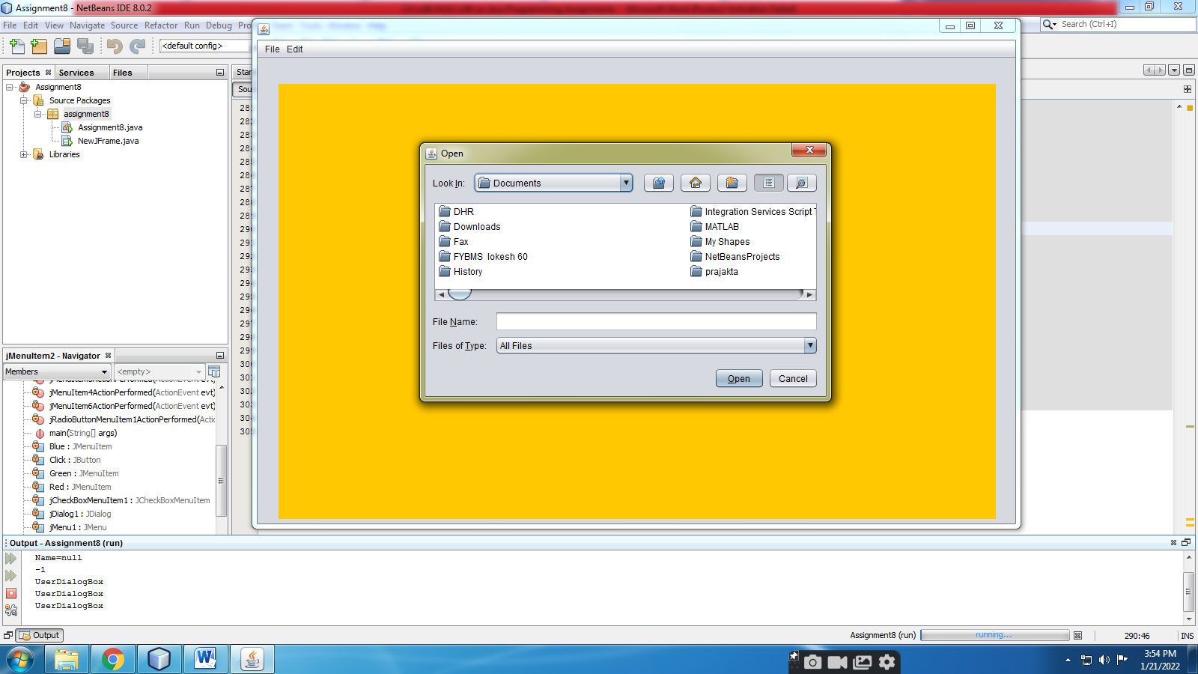

**Assignment 9) Write a program that demonstrate event handling for various types of events.**

Steps:-

1. Right Click on your project- New-JFrame
2. Drag JPanel on JFrame
3. Drag JButton, JTextField on JPanel
4. Right Click on JButton, JTextField-Edit Text
5. Right Click on JButton, JTextField, JPanel-Events-select event/methods you want and write appropriate code.
6. Code

package assignment9;

**import java.awt.Color;**

public class NewJFrame extends javax.swing.JFrame {

public NewJFrame() {

initComponents();

}

@SuppressWarnings("unchecked")

// <editor-fold defaultstate="collapsed" desc="Generated Code">

private void initComponents() {

jPanel1 = new javax.swing.JPanel();

jButton2 = new javax.swing.JButton();

jTextField1 = new javax.swing.JTextField();

setDefaultCloseOperation(javax.swing.WindowConstants.EXIT_ON_CLOSE);

jPanel1.addMouseListener(new java.awt.event.MouseAdapter() {

public void mouseClicked(java.awt.event.MouseEvent evt) {

jPanel1MouseClicked(evt);

}

});

jButton2.setText("Mouse");

jButton2.addMouseListener(new java.awt.event.MouseAdapter() {

public void mouseEntered(java.awt.event.MouseEvent evt) {

jButton2MouseEntered(evt);

}

public void mouseExited(java.awt.event.MouseEvent evt) {

jButton2MouseExited(evt);

}

});

jTextField1.addKeyListener(new java.awt.event.KeyAdapter() {

public void keyTyped(java.awt.event.KeyEvent evt) {

jTextField1KeyTyped(evt);

}

});

javax.swing.GroupLayout jPanel1Layout = new javax.swing.GroupLayout(jPanel1);

jPanel1.setLayout(jPanel1Layout);

jPanel1Layout.setHorizontalGroup(

jPanel1Layout.createParallelGroup(javax.swing.GroupLayout.Alignment.LEADING)

.addGroup(jPanel1Layout.createSequentialGroup()

.addGap(53, 53, 53)

.addComponent(jButton2, javax.swing.GroupLayout.PREFERRED_SIZE, 112, javax.swing.GroupLayout.PREFERRED_SIZE)

.addGap(81, 81, 81)

.addComponent(jTextField1, javax.swing.GroupLayout.PREFERRED_SIZE, 95, javax.swing.GroupLayout.PREFERRED_SIZE)

.addContainerGap(635, Short.MAX_VALUE))

);

jPanel1Layout.setVerticalGroup(

jPanel1Layout.createParallelGroup(javax.swing.GroupLayout.Alignment.LEADING)

.addGroup(jPanel1Layout.createSequentialGroup()

.addGap(24, 24, 24)

.addGroup(jPanel1Layout.createParallelGroup(javax.swing.GroupLayout.Alignment.BASELINE)

.addComponent(jButton2, javax.swing.GroupLayout.PREFERRED_SIZE, 33, javax.swing.GroupLayout.PREFERRED_SIZE)

.addComponent(jTextField1, javax.swing.GroupLayout.PREFERRED_SIZE, 33, javax.swing.GroupLayout.PREFERRED_SIZE))

.addContainerGap(541, Short.MAX_VALUE))

);

javax.swing.GroupLayout layout = new javax.swing.GroupLayout(getContentPane());

getContentPane().setLayout(layout);

layout.setHorizontalGroup(

layout.createParallelGroup(javax.swing.GroupLayout.Alignment.LEADING)

.addGroup(layout.createSequentialGroup()

.addContainerGap()

.addComponent(jPanel1, javax.swing.GroupLayout.PREFERRED_SIZE, javax.swing.GroupLayout.DEFAULT_SIZE, javax.swing.GroupLayout.PREFERRED_SIZE)

.addContainerGap(19, Short.MAX_VALUE))

);

layout.setVerticalGroup(

layout.createParallelGroup(javax.swing.GroupLayout.Alignment.LEADING)

.addGroup(layout.createSequentialGroup()

.addContainerGap()

.addComponent(jPanel1, javax.swing.GroupLayout.PREFERRED_SIZE, javax.swing.GroupLayout.DEFAULT_SIZE, javax.swing.GroupLayout.PREFERRED_SIZE)

.addContainerGap(28, Short.MAX_VALUE))

);

pack();

}// </editor-fold>

private void jButton2MouseEntered(java.awt.event.MouseEvent evt) {

// TODO add your handling code here:

**jPanel1.setBackground(Color.red);**

}

private void jButton2MouseExited(java.awt.event.MouseEvent evt) {

// TODO add your handling code here:

**jPanel1.setBackground(Color.GREEN);**

}

private void jTextField1KeyTyped(java.awt.event.KeyEvent evt) {

// TODO add your handling code here:

**char a=evt.getKeyChar();**

**if(a=='r' || a=='R')**

**{**

**jPanel1.setBackground(Color.red);**

**}**

**else if(a=='g' || a=='G')**

**{**

**jPanel1.setBackground(Color.GREEN);**

**}**

**else**

**{**

**jPanel1.setBackground(Color.BLACK);**

**}**

}

**int count=0;**

private void jPanel1MouseClicked(java.awt.event.MouseEvent evt) {

// TODO add your handling code here:

**count++;**

**if(count==1)**

**jPanel1.setBackground(Color.RED);**

**else if(count==2)**

**jPanel1.setBackground(Color.GREEN);**

**else if(count==3)**

**jPanel1.setBackground(Color.BLUE);**

**else**

**count=0;**

}

public static void main(String args[]) {

/* Set the Nimbus look and feel */

//<editor-fold defaultstate="collapsed" desc=" Look and feel setting code (optional) ">

/* If Nimbus (introduced in Java SE 6) is not available, stay with the default look and feel.

* For details see http://download.oracle.com/javase/tutorial/uiswing/lookandfeel/plaf.html

*/

try {

for (javax.swing.UIManager.LookAndFeelInfo info : javax.swing.UIManager.getInstalledLookAndFeels()) {

if ("Nimbus".equals(info.getName())) {

javax.swing.UIManager.setLookAndFeel(info.getClassName());

break;

}

}

} catch (ClassNotFoundException ex) {

java.util.logging.Logger.getLogger(NewJFrame.class.getName()).log(java.util.logging.Level.SEVERE, null, ex);

} catch (InstantiationException ex) {

java.util.logging.Logger.getLogger(NewJFrame.class.getName()).log(java.util.logging.Level.SEVERE, null, ex);

} catch (IllegalAccessException ex) {

java.util.logging.Logger.getLogger(NewJFrame.class.getName()).log(java.util.logging.Level.SEVERE, null, ex);

} catch (javax.swing.UnsupportedLookAndFeelException ex) {

java.util.logging.Logger.getLogger(NewJFrame.class.getName()).log(java.util.logging.Level.SEVERE, null, ex);

}

//</editor-fold>

/* Create and display the form */

java.awt.EventQueue.invokeLater(new Runnable() {

public void run() {

new NewJFrame().setVisible(true);

}

});

}

// Variables declaration - do not modify

private javax.swing.JButton jButton2;

private javax.swing.JPanel jPanel1;

private javax.swing.JTextField jTextField1;

// End of variables declaration

}

1. Right Click in Code-Run File

**OUTPUT:-**

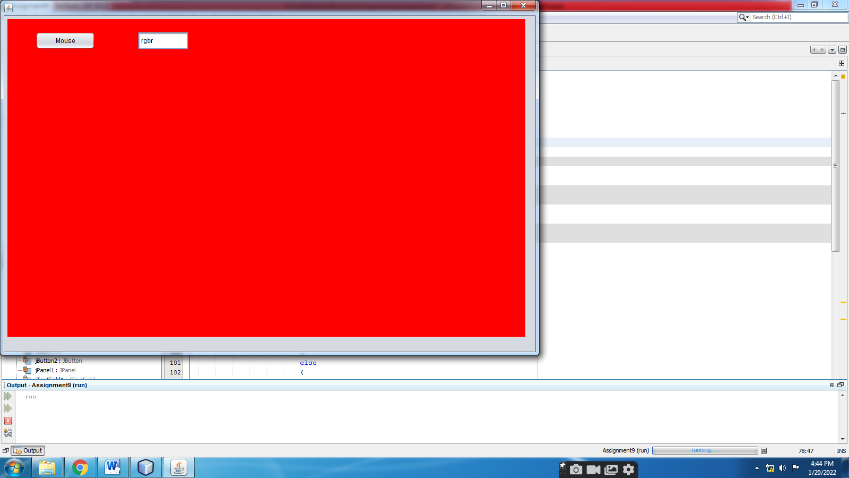

**Assignment 10) Write a program to illustrate multithreading.**

package assignment10;

class TestSleepMethod1 extends Thread

{

public void run()

{

for(int i=1;i<=5;i++)

{

try

{

System.out.println(i);

Thread.sleep(500);

}

catch(InterruptedException e)

{

System.out.println(e);

}

}

}

}

public class Assignment10

{

public static void main(String[] args)

{

TestSleepMethod1 t1=new TestSleepMethod1();

TestSleepMethod1 t2=new TestSleepMethod1();

TestSleepMethod1 t3=new TestSleepMethod1();

t1.start();

t2.start();

t3.start();

}

}

**OUTPUT:-**

1

1

1

2

2

2

3

3

3

4

4

4

5

5

5

**Assignment 11) Write a program to illustrate exception handling.**

package assignment11;

public class Assignment11

{

public static void main(String[] args)

{

try

{

int i=2/0;

int a[]=new int[5];

a[10]=30;

}

catch(ArrayIndexOutOfBoundsException e)

{

System.out.println("ArrayIndexOutOfBoundsException");

}

catch(ArithmeticException e)

{

System.out.println("ArithmeticException");

}

catch(Exception e)

{

System.out.println("Exception");

}

finally

{

System.out.println("Finally");

}

}

}

**OUTPUT:-**

ArithmeticException

Finally

**Assignment 12) Write a program to demonstrate use of File class.**

package assignment12;

import java.io.*;

public class Assignment12

{

public static void main(String[] args)

{

FileInputStream sourceStream = null; //FileReader for char by char

FileOutputStream targetStream = null; //FileWriter for char by char

try

{

sourceStream= new FileInputStream("sorcefile.txt");

targetStream= new FileOutputStream("targetfile.txt");

// Reading source file and writing

// content to target file byte by byte

int temp;

while ((temp = sourceStream.read())!= -1)

{

targetStream.write(temp);

}

sourceStream.close();

targetStream.close();

}

catch(Exception e)

{

System.out.println("Exception");

}

//File class

File f = new File("sorcefile.txt");

System.out.println("The name of the file is: " + f.getName());

System.out.println("The absolute path of the file is: " + f.getAbsolutePath());

System.out.println("Is file writeable?: " + f.canWrite());

System.out.println("Is file readable " + f.canRead());

System.out.println("The size of the file in bytes is: " + f.length());

System.out.println("File Exist "+f.exists());

System.out.println("Is File or Directory "+f.isFile());

System.out.println("Is File or Directory "+f.isDirectory());

System.out.println("Is Hidden "+f.isHidden());

System.out.println("Last Modified Time: " + f.lastModified());

}

}

**OUTPUT:**

The name of the file is: sorcefile.txt

The absolute path of the file is: F:\M.S.Sonawane\2021-22\Java\Assignment12\sorcefile.txt

Is file writeable?: true

Is file readable true

The size of the file in bytes is: 46

File Exist true

Is File or Directory true

Is File or Directory false

Is Hidden false

Last Modified Time: 1642157554913

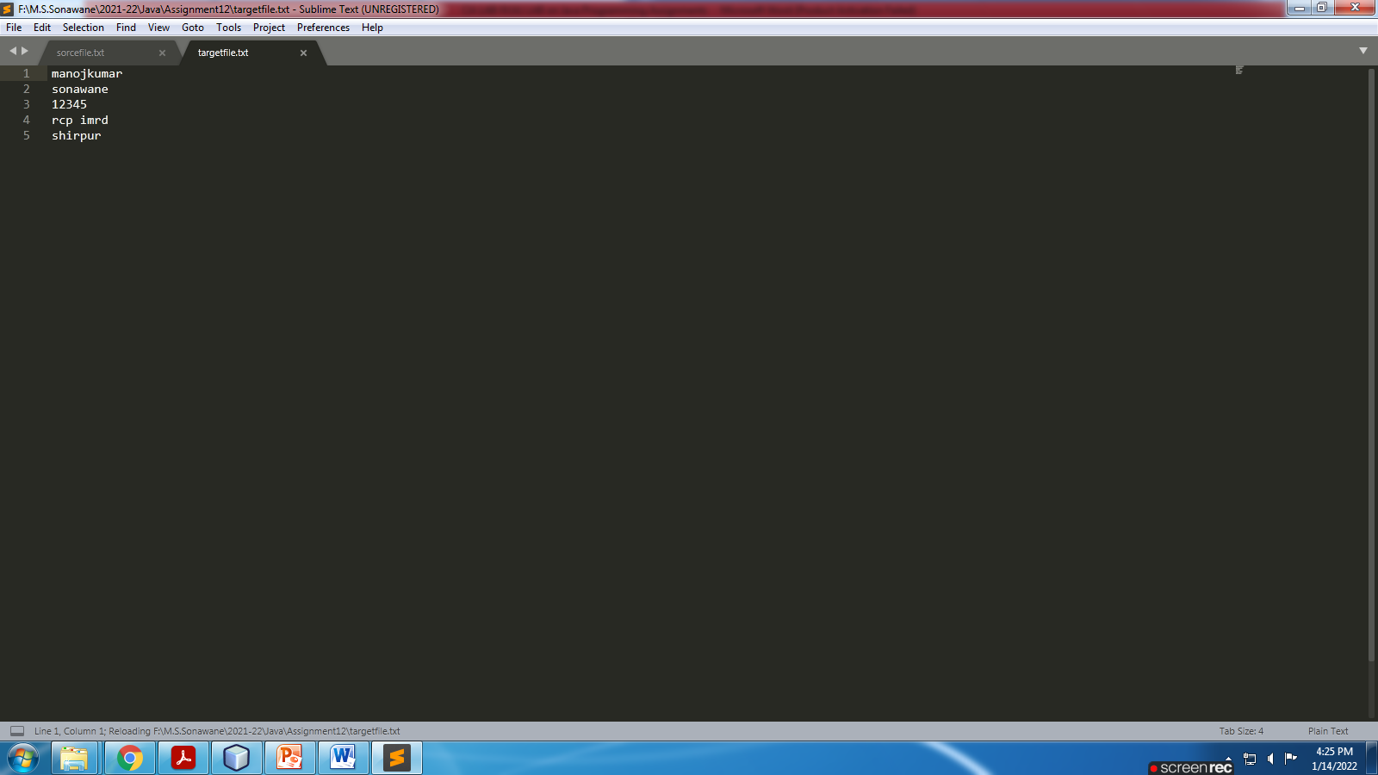

**Assignment 13) Write a program that demonstrate JDBC on application.**

Steps:-

1. Right Click on your project- New-JFrame
2. Drag JPanel on JFrame
3. Drag 2 JLabels, 2 JTextFields, 4 JButtons on JPanel
4. Right Click on all-Edit Text
5. Create Database
6. Create DSN and connect it to Database.
7. Connect DSN to your application in NetBeans.
8. Right Click on 4 JButtons-Events-select event/methods you want and write appropriate code.
9. Code

package assignment13;

**import java.sql.*;**

public class NewJFrame extends javax.swing.JFrame {

public NewJFrame() {

initComponents();

}

@SuppressWarnings("unchecked")

// <editor-fold defaultstate="collapsed" desc="Generated Code">

private void initComponents() {

jPanel1 = new javax.swing.JPanel();

jLabel1 = new javax.swing.JLabel();

jTextField1 = new javax.swing.JTextField();

jLabel2 = new javax.swing.JLabel();

jTextField2 = new javax.swing.JTextField();

jButton1 = new javax.swing.JButton();

jButton2 = new javax.swing.JButton();

jButton3 = new javax.swing.JButton();

jButton4 = new javax.swing.JButton();

setDefaultCloseOperation(javax.swing.WindowConstants.EXIT_ON_CLOSE);

jLabel1.setText("RNo");

jLabel2.setText("Name");

jButton1.setText("Insert");

jButton1.addActionListener(new java.awt.event.ActionListener() {

public void actionPerformed(java.awt.event.ActionEvent evt) {

jButton1ActionPerformed(evt);

}

});

jButton2.setText("Update");

jButton2.addActionListener(new java.awt.event.ActionListener() {

public void actionPerformed(java.awt.event.ActionEvent evt) {

jButton2ActionPerformed(evt);

}

});

jButton3.setText("Delete");

jButton3.addActionListener(new java.awt.event.ActionListener() {

public void actionPerformed(java.awt.event.ActionEvent evt) {

jButton3ActionPerformed(evt);

}

});

jButton4.setText("Select");

jButton4.addActionListener(new java.awt.event.ActionListener() {

public void actionPerformed(java.awt.event.ActionEvent evt) {

jButton4ActionPerformed(evt);

}

});

javax.swing.GroupLayout jPanel1Layout = new javax.swing.GroupLayout(jPanel1);

jPanel1.setLayout(jPanel1Layout);

jPanel1Layout.setHorizontalGroup(

jPanel1Layout.createParallelGroup(javax.swing.GroupLayout.Alignment.LEADING)

.addGroup(jPanel1Layout.createSequentialGroup()

.addGap(83, 83, 83)

.addGroup(jPanel1Layout.createParallelGroup(javax.swing.GroupLayout.Alignment.LEADING, false)

.addComponent(jButton1, javax.swing.GroupLayout.DEFAULT_SIZE, 72, Short.MAX_VALUE)

.addComponent(jLabel1, javax.swing.GroupLayout.DEFAULT_SIZE, javax.swing.GroupLayout.DEFAULT_SIZE, Short.MAX_VALUE)

.addComponent(jLabel2, javax.swing.GroupLayout.PREFERRED_SIZE, 53, javax.swing.GroupLayout.PREFERRED_SIZE))

.addPreferredGap(javax.swing.LayoutStyle.ComponentPlacement.RELATED)

.addGroup(jPanel1Layout.createParallelGroup(javax.swing.GroupLayout.Alignment.LEADING)

.addGroup(jPanel1Layout.createSequentialGroup()

.addComponent(jButton2, javax.swing.GroupLayout.PREFERRED_SIZE, 83, javax.swing.GroupLayout.PREFERRED_SIZE)

.addPreferredGap(javax.swing.LayoutStyle.ComponentPlacement.UNRELATED)

.addComponent(jButton3, javax.swing.GroupLayout.PREFERRED_SIZE, 81, javax.swing.GroupLayout.PREFERRED_SIZE)

.addPreferredGap(javax.swing.LayoutStyle.ComponentPlacement.UNRELATED)

.addComponent(jButton4, javax.swing.GroupLayout.PREFERRED_SIZE, 89, javax.swing.GroupLayout.PREFERRED_SIZE))

.addComponent(jTextField2, javax.swing.GroupLayout.PREFERRED_SIZE, 106, javax.swing.GroupLayout.PREFERRED_SIZE)

.addComponent(jTextField1, javax.swing.GroupLayout.PREFERRED_SIZE, 74, javax.swing.GroupLayout.PREFERRED_SIZE))

.addContainerGap(569, Short.MAX_VALUE))

);

jPanel1Layout.setVerticalGroup(

jPanel1Layout.createParallelGroup(javax.swing.GroupLayout.Alignment.LEADING)

.addGroup(jPanel1Layout.createSequentialGroup()

.addGap(56, 56, 56)

.addGroup(jPanel1Layout.createParallelGroup(javax.swing.GroupLayout.Alignment.BASELINE)

.addComponent(jLabel1, javax.swing.GroupLayout.PREFERRED_SIZE, 23, javax.swing.GroupLayout.PREFERRED_SIZE)

.addComponent(jTextField1, javax.swing.GroupLayout.PREFERRED_SIZE, 23, javax.swing.GroupLayout.PREFERRED_SIZE))

.addGap(33, 33, 33)

.addGroup(jPanel1Layout.createParallelGroup(javax.swing.GroupLayout.Alignment.BASELINE)

.addComponent(jLabel2, javax.swing.GroupLayout.PREFERRED_SIZE, 26, javax.swing.GroupLayout.PREFERRED_SIZE)

.addComponent(jTextField2, javax.swing.GroupLayout.PREFERRED_SIZE, 26, javax.swing.GroupLayout.PREFERRED_SIZE))

.addGap(62, 62, 62)

.addGroup(jPanel1Layout.createParallelGroup(javax.swing.GroupLayout.Alignment.LEADING, false)

.addGroup(jPanel1Layout.createParallelGroup(javax.swing.GroupLayout.Alignment.BASELINE)

.addComponent(jButton2, javax.swing.GroupLayout.DEFAULT_SIZE, javax.swing.GroupLayout.DEFAULT_SIZE, Short.MAX_VALUE)

.addComponent(jButton3, javax.swing.GroupLayout.DEFAULT_SIZE, javax.swing.GroupLayout.DEFAULT_SIZE, Short.MAX_VALUE)

.addComponent(jButton4, javax.swing.GroupLayout.DEFAULT_SIZE, javax.swing.GroupLayout.DEFAULT_SIZE, Short.MAX_VALUE))

.addComponent(jButton1, javax.swing.GroupLayout.DEFAULT_SIZE, javax.swing.GroupLayout.DEFAULT_SIZE, Short.MAX_VALUE))

.addContainerGap(362, Short.MAX_VALUE))

);

javax.swing.GroupLayout layout = new javax.swing.GroupLayout(getContentPane());

getContentPane().setLayout(layout);

layout.setHorizontalGroup(

layout.createParallelGroup(javax.swing.GroupLayout.Alignment.LEADING)

.addGroup(layout.createSequentialGroup()

.addContainerGap()

.addComponent(jPanel1, javax.swing.GroupLayout.DEFAULT_SIZE, javax.swing.GroupLayout.DEFAULT_SIZE, Short.MAX_VALUE)

.addContainerGap())

);

layout.setVerticalGroup(

layout.createParallelGroup(javax.swing.GroupLayout.Alignment.LEADING)

.addGroup(layout.createSequentialGroup()

.addContainerGap()

.addComponent(jPanel1, javax.swing.GroupLayout.PREFERRED_SIZE, javax.swing.GroupLayout.DEFAULT_SIZE, javax.swing.GroupLayout.PREFERRED_SIZE)

.addContainerGap(42, Short.MAX_VALUE))

);

pack();

}// </editor-fold>

private void jButton1ActionPerformed(java.awt.event.ActionEvent evt) {

// TODO add your handling code here:

**try**

**{**

**Class.forName("sun.jdbc.odbc.JdbcOdbcDriver");**

**Connection c=DriverManager.getConnection("jdbc:odbc:dsn1"," "," ");**

**Statement st=c.createStatement();;**

**String s1=jTextField1.getText();**

**int i=Integer.parseInt(s1);**

**String s2=jTextField2.getText();**

**int count=st.executeUpdate("insert into student values("+i+",'"+s2+"')");**

**System.out.println("Record Inserted "+count);**

**}**

**catch(Exception e)**

**{**

**System.out.println("Insert Exp "+e);**

**}**

}

private void jButton2ActionPerformed(java.awt.event.ActionEvent evt) {

// TODO add your handling code here:

**try**

**{**

**Class.forName("sun.jdbc.odbc.JdbcOdbcDriver");**

**Connection c=DriverManager.getConnection("jdbc:odbc:dsn1"," "," ");**

**Statement st=c.createStatement();;**

**String s1=jTextField1.getText();**

**int i=Integer.parseInt(s1);**

**String s2=jTextField2.getText();**

**int count=st.executeUpdate("update student set sname='"+s2+"' where rno="+i+"");**

**System.out.println("Record Updated "+count);**

**}**

**catch(Exception e)**

**{**

**System.out.println("Update Exp "+e);**

**}**

}

private void jButton3ActionPerformed(java.awt.event.ActionEvent evt) {

// TODO add your handling code here:

**try**

**{**

**Class.forName("sun.jdbc.odbc.JdbcOdbcDriver");**

**Connection c=DriverManager.getConnection("jdbc:odbc:dsn1"," "," ");**

**Statement st=c.createStatement();;**

**String s1=jTextField1.getText();**

**int i=Integer.parseInt(s1);**

**int count=st.executeUpdate("delete * from student where rno="+i+"");**

**System.out.println("Record Deleted "+count);**

**}**

**catch(Exception e)**

**{**

**System.out.println("Delete Exp "+e);**

**}**

}

private void jButton4ActionPerformed(java.awt.event.ActionEvent evt) {

// TODO add your handling code here:

**try**

**{**

**Class.forName("sun.jdbc.odbc.JdbcOdbcDriver");**

**Connection c=DriverManager.getConnection("jdbc:odbc:dsn1"," "," ");**

**Statement st=c.createStatement();;**

**String s1=jTextField1.getText();**

**int i=Integer.parseInt(s1);**

**ResultSet rs=st.executeQuery("select * from student where rno="+i+"");**

**while(rs.next())**

**{**

**jTextField2.setText(rs.getString("sname"));**

**}**

**}**

**catch(Exception e)**

**{**

**System.out.println("Select Exp "+e);**

**}**

}

/**

* @param args the command line arguments

*/

public static void main(String args[]) {

/* Set the Nimbus look and feel */

//<editor-fold defaultstate="collapsed" desc=" Look and feel setting code (optional) ">

/* If Nimbus (introduced in Java SE 6) is not available, stay with the default look and feel.

* For details see http://download.oracle.com/javase/tutorial/uiswing/lookandfeel/plaf.html

*/

try {

for (javax.swing.UIManager.LookAndFeelInfo info : javax.swing.UIManager.getInstalledLookAndFeels()) {

if ("Nimbus".equals(info.getName())) {

javax.swing.UIManager.setLookAndFeel(info.getClassName());

break;

}

}

} catch (ClassNotFoundException ex) {

java.util.logging.Logger.getLogger(NewJFrame.class.getName()).log(java.util.logging.Level.SEVERE, null, ex);

} catch (InstantiationException ex) {

java.util.logging.Logger.getLogger(NewJFrame.class.getName()).log(java.util.logging.Level.SEVERE, null, ex);

} catch (IllegalAccessException ex) {

java.util.logging.Logger.getLogger(NewJFrame.class.getName()).log(java.util.logging.Level.SEVERE, null, ex);

} catch (javax.swing.UnsupportedLookAndFeelException ex) {

java.util.logging.Logger.getLogger(NewJFrame.class.getName()).log(java.util.logging.Level.SEVERE, null, ex);

}

//</editor-fold>

/* Create and display the form */

java.awt.EventQueue.invokeLater(new Runnable() {

public void run() {

new NewJFrame().setVisible(true);

}

});

}

// Variables declaration - do not modify

private javax.swing.JButton jButton1;

private javax.swing.JButton jButton2;

private javax.swing.JButton jButton3;

private javax.swing.JButton jButton4;

private javax.swing.JLabel jLabel1;

private javax.swing.JLabel jLabel2;

private javax.swing.JPanel jPanel1;

private javax.swing.JTextField jTextField1;

private javax.swing.JTextField jTextField2;

// End of variables declaration

}

1. Right Click in Code-Run File

**OUTPUT:-**

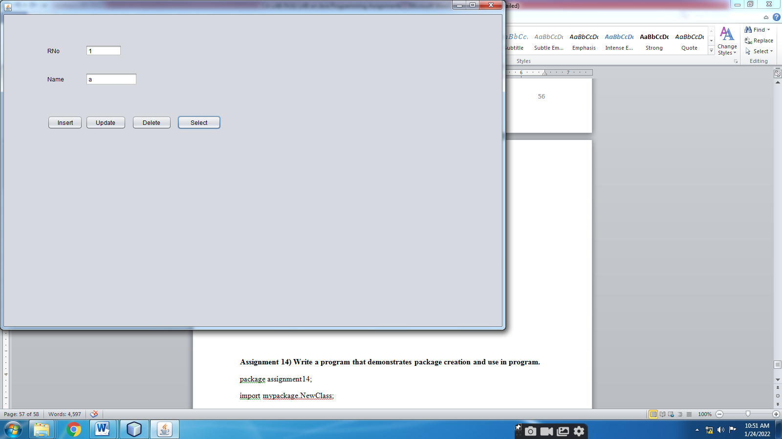

**Assignment 14) Write a program that demonstrates package creation and use in program.**

package assignment14;

import mypackage.NewClass;

public class Assignment14

{

public static void main(String[] args)

{

NewClass n=new NewClass();

n.show();

}

}

//Create mypackage, Create NewClass

package mypackage;

public class NewClass

{

public void show()

{

System.out.println("Show Method is Called");

}

}

**OUTPUT:-**

Show Method is Called